How to Add PWA to Android Device’s Home Page
Direct URL:
https://treasury.fcbanking.com/pwa/fcbanking/login
- Click the three dots in the upper right hand corner.
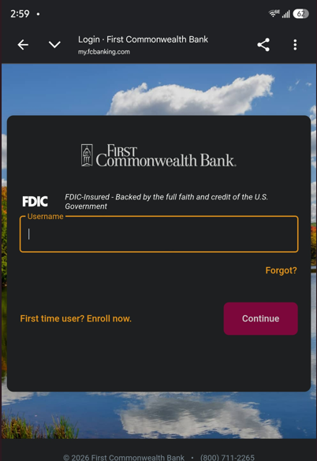
- Click ‘Desktop site’.
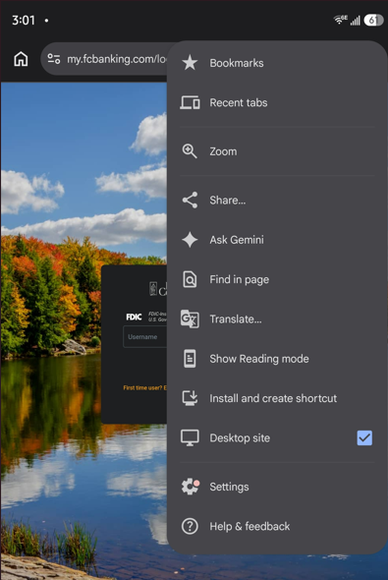
- You will be prompted to Install or Create shortcut. Click ‘Create shortcut’
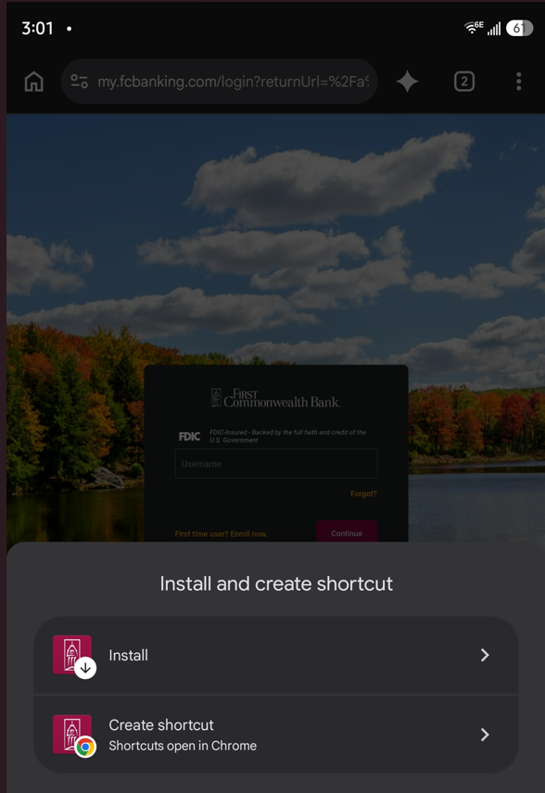
- Rename your shortcut. In the example below, we used Treasury Management. Once finished click ‘Add’.
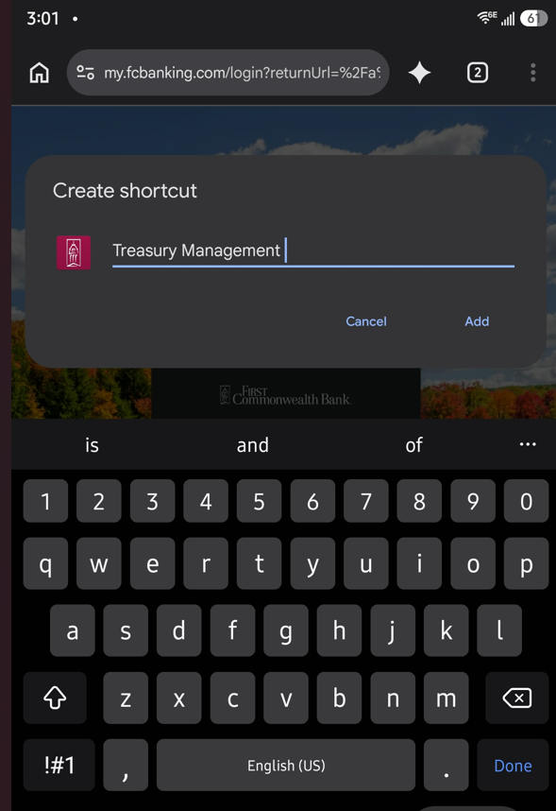
- You will be prompted to add the shortcut to your Home screen. Click ‘Add’.
