How to Add PWA to Apple Device’s Home Page
Direct URL:
https://treasury.fcbanking.com/pwa/fcbanking/login
- Click the share icon.
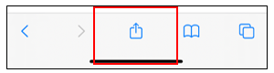
- Scroll until you find ‘Add to Home Screen’.
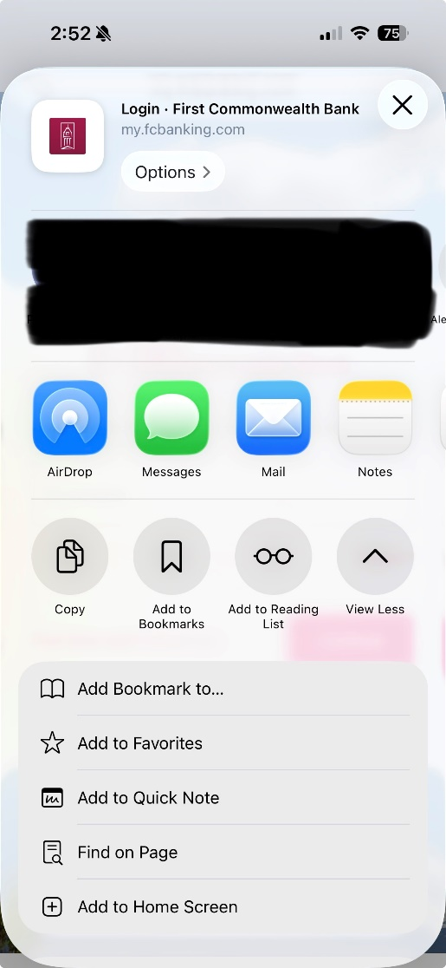
- Customers can rename the tile if they would like.
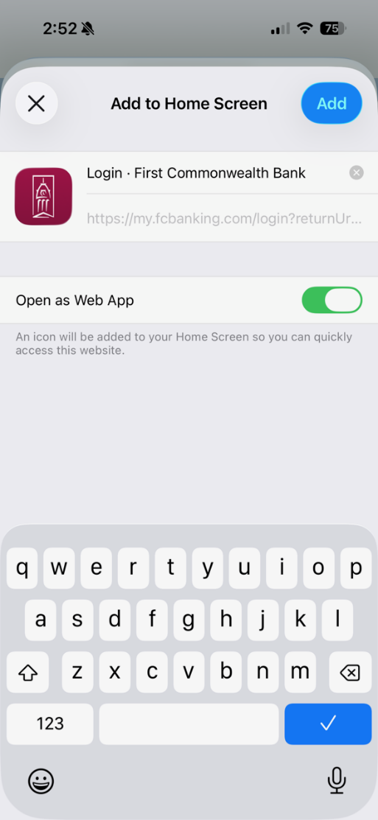
- Once finished, click done and the tile will on the user’s home screen.
